**Probability Lab 4**

Anudit Nagar - E18CSE024

Question 1

CODE

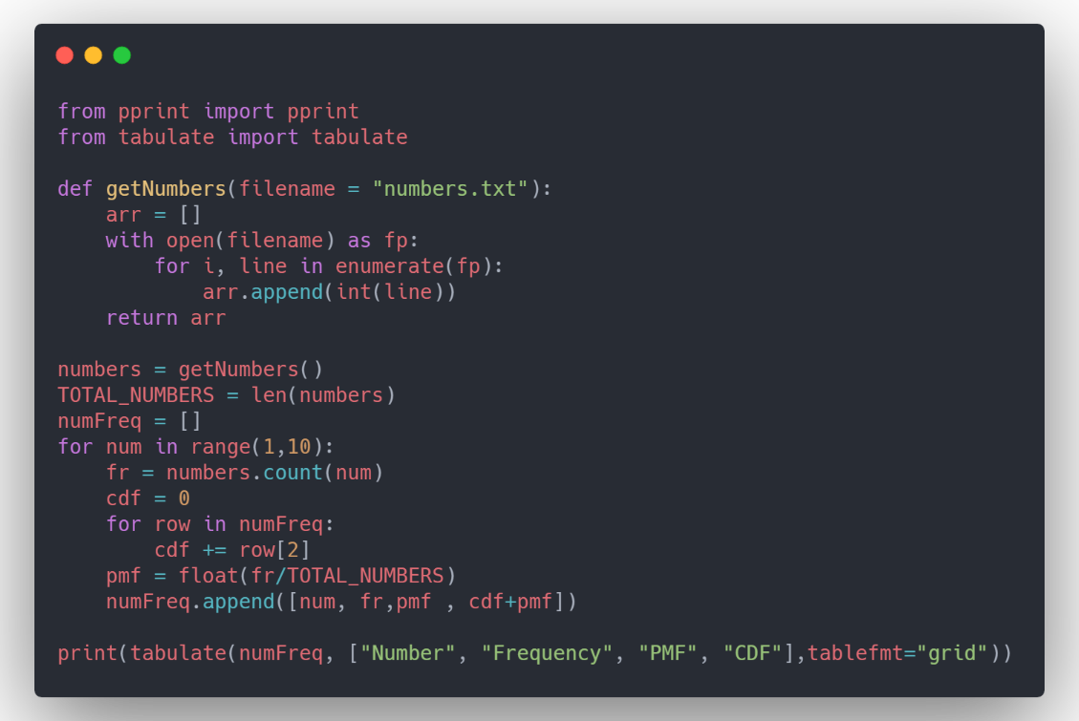

OUTPUT

+----------+-------------+--------+--------+

| Number | Frequency | PMF | CDF |

+==========+=============+========+========+

| 1 | 2985 | 0.2985 | 0.2985 |

+----------+-------------+--------+--------+

| 2 | 1765 | 0.1765 | 0.475 |

+----------+-------------+--------+--------+

| 3 | 1273 | 0.1273 | 0.6023 |

+----------+-------------+--------+--------+

| 4 | 944 | 0.0944 | 0.6967 |

+----------+-------------+--------+--------+

| 5 | 793 | 0.0793 | 0.776 |

+----------+-------------+--------+--------+

| 6 | 637 | 0.0637 | 0.8397 |

+----------+-------------+--------+--------+

| 7 | 592 | 0.0592 | 0.8989 |

+----------+-------------+--------+--------+

| 8 | 517 | 0.0517 | 0.9506 |

+----------+-------------+--------+--------+

| 9 | 494 | 0.0494 | 1 |

+----------+-------------+--------+--------+

Question 2

CODE

OUTPUT

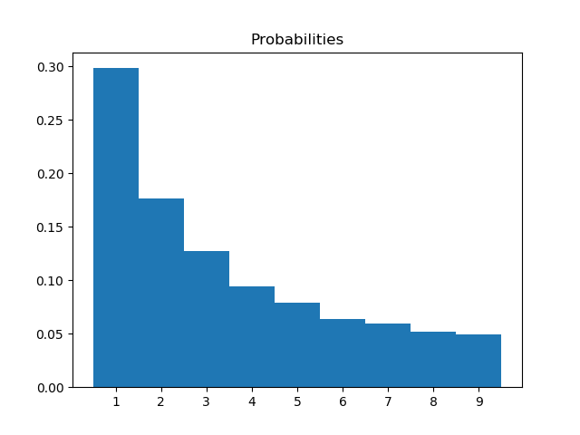

Question 3

CODE

**OUTPUT**



